SMART VENT® ENGINEERED FLOOD VENTS
3-PART SPECIFICATIONS
SECTION 089543
FLOOD VENTS

**Note to Specifier** This specification contains component and configuration options. Where indicated,
choose the appropriate choice for your specific project requirements. Delete specifier instructions prior to publishing completed specification.
PART 1 – GENERAL

1.1 SUMMARY
A. Work Results:
1. Installation of Flood Vents: Factory assembled stainless steel flood vents.
B. Principal Products:
1. Engineered Stainless Steel Flood Vents.
C. Section Includes:
- Engineered Stainless Steel Flood Vents.
  - Insulated Models.
  - Dual-Function Models.
- Insulated Sealing Kits.
- Fire Dampers.
- Trim and Sleeve Kits.
- Accessories.
1.2 REFERENCES
A. International Residential Code (IRC), latest edition as approved by the authorities having jurisdiction.
B. International Building Code (IBC), latest edition as approved by the authorities having jurisdiction.
C. International Code Council Evaluation Service (ICC-ES) Acceptance Criteria for Mechanically Operated Flood Vents (AC-364), latest edition.
D. <State> Building Code, latest edition as approved by the authorities having jurisdiction.
E. ASCE/SEI 24 “Flood Resistant Design and Construction”, latest edition.
F. Code of Federal Regulations (CFR), Title 44.
G. Federal Emergency Management Agency (FEMA) Regulations, latest.
H. National Flood Insurance Program (NFIP) Regulations, latest.
I. FEMA/NFIP Technical Bulletin 1 “Openings in Foundation Walls and Walls of Enclosures”, latest edition.
J. FEMA/NFIP Technical Bulletin 2 “Flood Damage-Resistant Materials Requirements”, latest edition.
K. International Energy Conservation Code (IECC), latest edition as approved by the authorities having jurisdiction.
L. Abu Dhabi International Building Code (ADIBC), latest edition as approved by the authorities having jurisdiction.

1.3 ADMINISTRATIVE PROCEDURES
A. Coordination Procedures: Coordinate flood vent locations with existing architectural finishes.
B. Preinstallation Meeting Attendees and Procedures:
1. Conduct meeting [one week] [one month] [other scheduled time], minimum before starting work in this Section.
2. Additional Attendees: <List Attendees>.
3. Additional Agenda Items:
a. <Agenda Item>.
b. <Agenda Item>.
c. <Agenda Item>.
1.4 ACTION SUBMITTALS
A. Product Data: Provide manufacturer’s information on each material and component of the vent.
B. Manufacturer's Certificates: Certify products meet or exceed specified requirements.
1.5 INFORMATIONAL SUBMITTALS
A. Qualification Statements: For the [manufacturer], [installer], and/or [professional engineer].
B. Test and Evaluation Reports: Manufacturer test results showing flood protection coverage per product.
C. Manufacturer’s instructions.
1.6 CLOSEOUT SUBMITTALS
A. Maintenance Manual.
B. Warranty Documentation.
1.7 QUALITY ASSURANCE
A. Qualifications:
1. Manufacturer: Five (5) years of documented experience, minimum, in the manufacture of the products specified in this Section.

**Note to Specifier** Paragraph 1.7.A.2 and 1.7.A.3 below can be deleted if not required.

2. Installer: Three (3) years of experience, minimum, in the installation of the products specified in this Section.

3. Licensed Professional Engineer: A professional engineer specialized in the work specified in this Section and licensed in the State in which the project is located.

1.8 DELIVERY, STORAGE, AND HANDLING
A. Deliver products in manufacturer’s unopened packaging with labels undamaged, legible, and readable until ready for installation. Inspect materials for damages.
B. Protect stored materials from moisture exposure.
C. Store materials in a dry, cool, ventilated, and weathertight location.
D. Outdoor Storage Requirements (if necessary): Store materials on an incline to avoid moisture accumulation and facilitate runoff. Cover materials with a tarp set up in a tent-like fashion and raised above the products to allow for air circulation and to avoid UV exposure. Keep all additional hardware in a dry, climate-controlled setting.

1.9 FIELD CONDITIONS
A. Ambient Conditions: Perform work within manufacturer’s recommended weather and temperature limitations.

B. Existing Conditions: Verify field measurements before fabrication. Show field measurements on Shop Drawings.
a. Have flood vent manufacturer, installer, or qualified person(s) conduct site survey to document the conditions at the installation site to detail the type of materials, dimensions, configuration, potential interferences with the mounting surface, and any other contributing factors for proper installation.

1.10 WARRANTY
A. Manufacturer Warranty:
1. Warrant product to be free from defects in material and workmanship for a period of one (1) year from date of shipment.
2. Manufacturer offers 15-year extended warranty with product registration.

PART 2 PRODUCTS
2.1 MANUFACTURERS
A. Approved Manufacturer: Smart Vent Products, Inc., which is located at: 19 Mantua Road, Mount Royal, NJ, 08061; Telephone: 877-441-8368; Email: info@smartvent.com; Website: www.smartvent.com.
B. Substitutions: Not permitted.
C. Single Source Responsibilities: Obtain all flood vent assemblies from single manufacturer.

2.2 PERFORMANCE REQUIREMENTS
A. General: Flood Vents are constructed of Marine Grade 316 Stainless Steel formed and smooth-welded with a rigid construction. Frames are designed for installation in masonry, concrete, or framed walls, stud walls, garage doors and metal panels. Vents have a pivoting door assembly that is fitted with two patented sealed floats that provide vermin protection and immediately and automatically release the door upon contact with rising water to relieve unbalanced lateral forces on foundation walls. All flood vents are required to work bi- directionally, without human intervention.
B. Engineering Code Practices: Engineer flood products to conform to the design requirements that are based on the latest adopted editions of ASCE 24, International Residential Code (IRC), and the International Building Code (IBC).
C. Design Criteria: Conform to the requirements for A and AE Zones as set forth by the National Flood Insurance Program (NFIP).
1. Design flood vent model(s), quantity, and location to satisfy flood ventilation and
placement requirements for building enclosure.
D. Product Criteria:
1. Certifications:
a. International Code Council - Evaluation Service Report (ESR-2074) including Florida Building and Residential Code Supplement, California Building and Residential Code Supplement.
b. Florida Building Product Approval (FL5822) approved for use in High Velocity Hurricane Zones (HVHZ) and impact rated garage doors.

2.3 PRODUCTS
**Note to Specifier** Edit the following paragraphs as required and applicable to project requirements. Select the type and the model required. Delete those not required.

A. Dual Function Flood Vent Series: Provide both flood protection and natural air ventilation. Louvered blades are temperature controlled with a bimetal coil and the screen is vermin resistant:
1. SMART VENT Products Model #1540-510: Ventilated with Louvered Blades and Screen.
a. Flood Coverage: 200 sq. ft.
b. Air Ventilation: 51 sq.in.
c. Size: 16 inches W by 8 inches H by 3 inches D.
d. Rough Opening: 16-1/4 inches W by 8-1/4 inches H.
2. SMART VENT Products Model #1540-511 Double or Stacking Model: Ventilated with Louvered Blades and Screen.
a. Flood Coverage: 400 sq. ft.
b. Air Ventilation: 102 sq.in.
c. Size: 16 inches W by 16 inches H by 3 inches D.
d. Rough Opening: 16-1/4 inches W by 16-3/8 inches H.
3. SMART VENT Products Model #1540-150202 (1540-0039) 2 x 2 Multi-frame: Ventilated with Louvered Blades and Screen.
a. Flood Coverage: 800 sq. ft.
b. Air Ventilation: 204 sq.in.
c. Size: 32-1/2 inches W by 16 inches H by 3 inches D.
d. Rough Opening: 33 inches W by 16-3/8 inches H.
4. SMART VENT Products Custom One-Piece Multi-Frame Model (316 SS Powder Coat):
a. Amount of vents wide: ______ (no more than six)
b. Amount of vents high: ______ (no more than three)
c. Flood Coverage: ______ sq. ft. (amount of vents multiplied by 200)
d. Air Ventilation: ______ sq. in. (amount of vents multiplied by 51)
B. Insulated Series: Provide flood protection only. Insulated Core with perimeter weather- stripping.
1. FLOOD VENT Products Model #1540-520: Flush or Solid Insulated Door.
a. Flood Coverage: 200 sq. ft.
b. Insulated Core R-Value: 8.34
c. Size: 16 inches W by 8 inches H by 3 inches D.
d. Rough Opening: 16-1/4 inches W by 8-1/4 inches H.
2. FLOOD VENT Products Model #1540-521 Stacking Model: Flush or Solid Insulated Doors.
a. Flood Coverage: 400 sq. ft.
b. Insulated core R-Value: 8.34
c. Size: 16 inches W by 16 inches H by 3 inches D.
d. Rough Opening: 16-1/4 inches W by 16-3/8 inches H.
3. FLOOD VENT Products Model #1540-150202 (1540-0239) 2 x 2 Multi-frame: Flush or Solid Insulated Door.
a. Flood Coverage: 800 sq. ft.
b. Insulated core R-Value: 8.34
c. Size: 32-1/2 inches W by 16 inches H by 3 inches D.
d. Rough Opening: 33 inches W by 16-3/8 inches H.
4. FLOOD VENT Products #1540-570 Wood Stud Wall Model: Flush or Solid Insulated Doors.
a. Flood Coverage: 200 sq. ft.
b. Insulated core R-Value: 8.34
c. Size: 14-1/2 inches W by 8-3/4 inches H by 3 inches D.
d. Rough Opening: 14-1/2 inches W by 8-3/4 inches H.
5. FLOOD VENT Products #1540-524 Overhead Garage Door Model: Flush or Solid Insulated Doors, standard finish powder-coated white.
a. Flood Coverage: 200 sq. ft.
b. Insulated core R-Value: 8.34
c. Size: 16 inches W by 8 inches H by 3 inches D.
d. Rough Opening: 16 inches W by 8 inches H.
6. FLOOD VENT Products #1540-574 Overhead Garage Door Model: Flush or Solid Insulated Doors, standard finish powder-coated white.
a. Flood Coverage: 200 sq. ft.
b. Insulated core R-Value: 8.34
c. Size: 14-1/2 inches W by 8-1/2 inches H by 3 inches D.
d. Rough Opening: 14-1/2 inches W by 8-1/2 inches H.
7. FLOOD VENT Products Custom One-Piece Multi-Frame Model (316 SS Powder Coat):
a. Amount of vents wide: ______ (no more than six)
b. Amount of vents high: ______ (no more than three)
c. Flood Coverage: ______ sq. ft. (amount of vents multiplied by 200)
C. Powder-Coat Finish with color as follows:
1. Black
2. White
3. Gray
4. Wheat
5. Custom (Sherwin-Williams or PPG Industries): __________________

D. Insulated Sealing Kit: Provides tight seal behind the vent opening – must be used in conjunction with a SMART VENT Insulated Model series vent. When a flood event occurs, the pre-cut Homasote® sealing material dislodges from the frame, creating an unobstructed opening to allow flood water to flow through freely. Installed on the interior wall. Finish: White.
1. For 16” W x 8” H vent models:
a. Flood Vent Sealing Kit Model #1540-526
2. For 16” W x 16” H vent models:
a. Flood Vent Sealing Kit Model #1540-526-2
3. For 32.5” W x 16” H vent models:
a. Flood Vent Sealing Kit Model #1540-526-4
4. Custom:
a. Amount of vents wide: ______ (no more than six)
b. Amount of vents high: ______ (no more than three)
E. Trim and Sleeves Kits: Sleeves for use in 'un-filled' masonry and for, Fire Walls where 'air-
space' is required on Exterior Walls and to finish off the inside of openings:
- For 16” W x 8” H vent models:
a. Adjustable Sleeve/Trim #1540-531-12: for 7 inches to 12.5 inches wall thickness.
b. Adjustable Sleeve/Trim #1540-531-15: for 10 inches to 15.5 inches wall
thickness.
- For 14.5” W x 8.5” H models:
a. Interior Trim Flange #1540-573, for 4 inches to 6.5 inches wall thickness.
b. Interior Trim Flange #1540-573, 9 inches to 11.5 inches wall thickness.
- For 16” W x 16” H models:
- Interior Trim Flange #1540-0507-01, for 6 inches to 8.5 inches wall thickness.
- For 32.5” W x 16” H models:
a. Adjustable Sleeve/Trim #1540-531-15: for 6 inches to 12 inches wall thickness.
- Custom Sleeve/Trim:
a. Amount of vents wide: ______ (no more than six)
b. Amount of vents high: ______ (no more than three)
c. Wall thickness: ____________
F. Fire Dampers: UL Rated.
Note: Trim flange and inner sleeve are required for installation, as well as an 8-inch minimum wall thickness. 2- or 3-hour fire resistance available.
1. Fire-Rated Damper Model #1540-530: 2-hour fire rated with fusible link damper. For use in masonry walls in conjunction with Dual Function Flood Vent Model #1540-510 or Insulated Flood Vent Model #1540-520.
2. Fire-Rated Damper Model #1540-537: 2-hour fire rated with fusible link damper. For use in wood walls in conjunction with Insulated Series Wood Wall Model #1540-570.
3. Fire Damper Custom Model:
a. Amount of vents wide: ______ (no more than six)
b. Amount of vents high: ______ (no more than three)
G. Accessories:
1. Included:
a. Installation Clips, four for each vent, with the exception for Wood Wall, Overhead Door, and Multi-frame models.
b. Security Clips, two for each vent.
2. Not Included:
a. Sealant: HurriBond™ (www.hurribond.com) or equivalent adhesive for masonry or concrete surfaces.
b. Adjustable wrench for thru-bolted models.
c. Stainless Steel screws and screwdriver for stud wall models.
PART 3 EXECUTION
3.1 EXAMINATION
A. Do not begin installation until substrates have been properly prepared.
B. Verify vent locations are ready to receive work, and dimensions are as indicated on shop drawings or as instructed by manufacturers.
C. If substrate preparation is the responsibility of another installer, notify Architect of unsatisfactory preparation before proceeding.
3.2 PREPARATION
A. Clean surfaces thoroughly prior to installation.
B. Review and coordinate setting drawings, templates, and related items that are to be embedded in concrete and masonry.
C. Verify that no obstructions exist that will interfere with the proper operation of the vents.
D. Prepare surfaces using the methods recommended by the manufacturer for achieving the best result for the substrate under the project conditions.

3.3 INSTALLATION
A. Install in accordance with manufacturer's instructions.
B. Install vents in at least two different walls spaced evenly around foundation perimeter and located a maximum of 12 inches higher than the interior or exterior grade, to the bottom of vent.
C. Install vents plumb, level, square, true to line, and rigid.
D. Attach vents securely in place using applicable manufactured approved adhesive, supplied or manufacturer approved fasteners, and installation clips.
E. Separate incompatible materials to prevent galvanic corrosion.
F. Install one single height flood vent for every 200 sq. ft. of enclosed space below floodplain.
G. Install one double height flood vent for every 400 sq. ft. of enclosed space below floodplain.
H. Install one quad assembly flood vent for every 800 sq. ft. of enclosed space below floodplain.
I. Install one multi-frame for every sq. ft. of enclosed space below the floodplain.
J. Adjust flood vents for proper operation.
3.4 FIELD QUALITY CONTROL
A. Field Tests and Inspections: Installer to perform float activation test to check flood door alignment. This is done by inserting two business cards (or similar items) into the two water-entry slots on the front or back of the flood door. This will simulate a flood event by dislodging the internal floats. The flood door should be able to swing freely in either direction. Once checked, installer will manually put the flood door positioned back in sitting position to engage the internal floats to latch.

3.5 CLEANING AND STORAGE
A. Inspect components for damages.
B. Touch-up minor damages to components to the satisfaction of the Architect. Replace components that are beyond repair.
C. Clean exposed surfaces.

3.6 PROTECTION
A. Protect installed product and finished surfaces during normal and general operation.
END OF SECTION

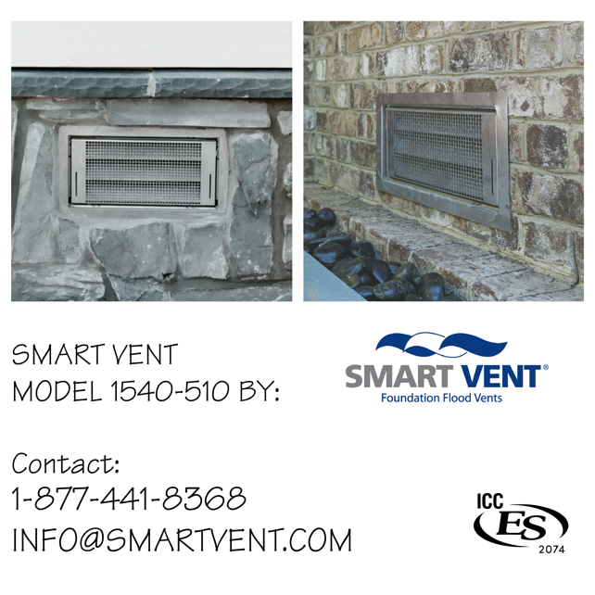
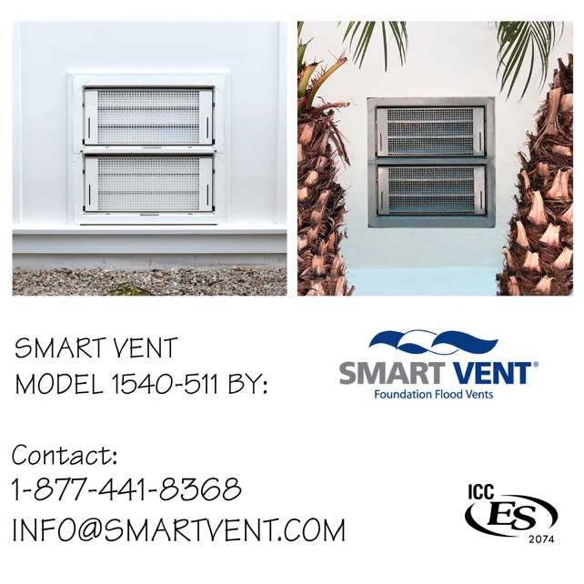
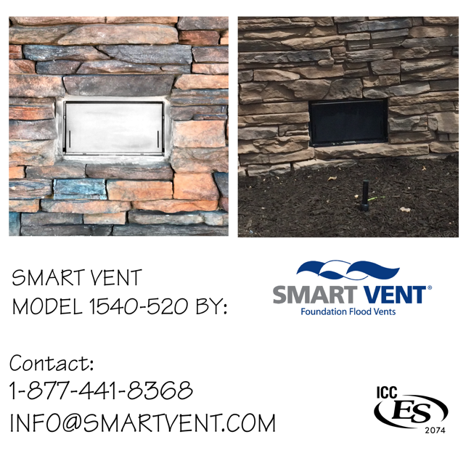
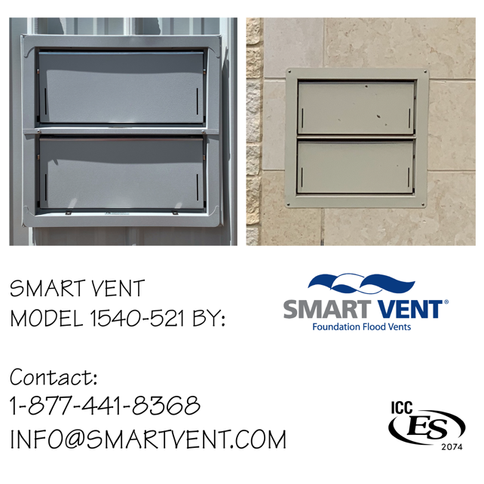
Please feel free to copy and paste the below graphics into your plans.

